Background
The overall aim is to address extreme poverty through the introduction of techniques and strategies for micro enterprise which will result in reduced levels of hunger and poor food security.

Activities

Food Production Units
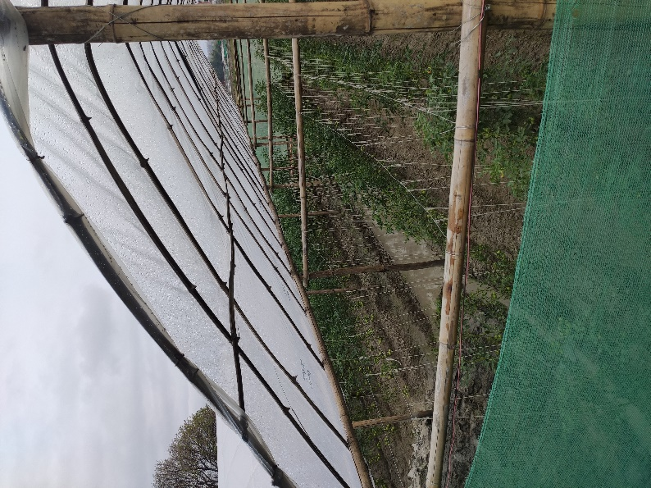
There is a high demand for both kitchen gardens and agricultural units throughout the project area. The introduction of these activities is always initiated as part of a training course to ensure that beneficiaries are in a position to maximise benefit. The use of greenhouses as food production units has become more popular as beneficiary groups recognise the advantage, they provide for growing crops out of the traditional growing season as well as protection for crops from adverse environmental conditions such as extreme precipitation and temperature and also as a way to protect crops from diseases and pests.

The last period focussed on supporting women groups to construct greenhouses and smaller food production units. In some case, community greenhouses were constructed and in others single units to benefit 1-2 households. A total of 26 groups benefitted form the activity. Sizes of greenhouses depended on space available, with the average greenhouse measuring 20m x 5m. Traditional building methods of using polythene sheets and rope and bamboo were utilised to contrast the units enabling more swift completion and utilisation of the growing areas. Women were trained in the construction and maintenance of the units to ensure sustainability.
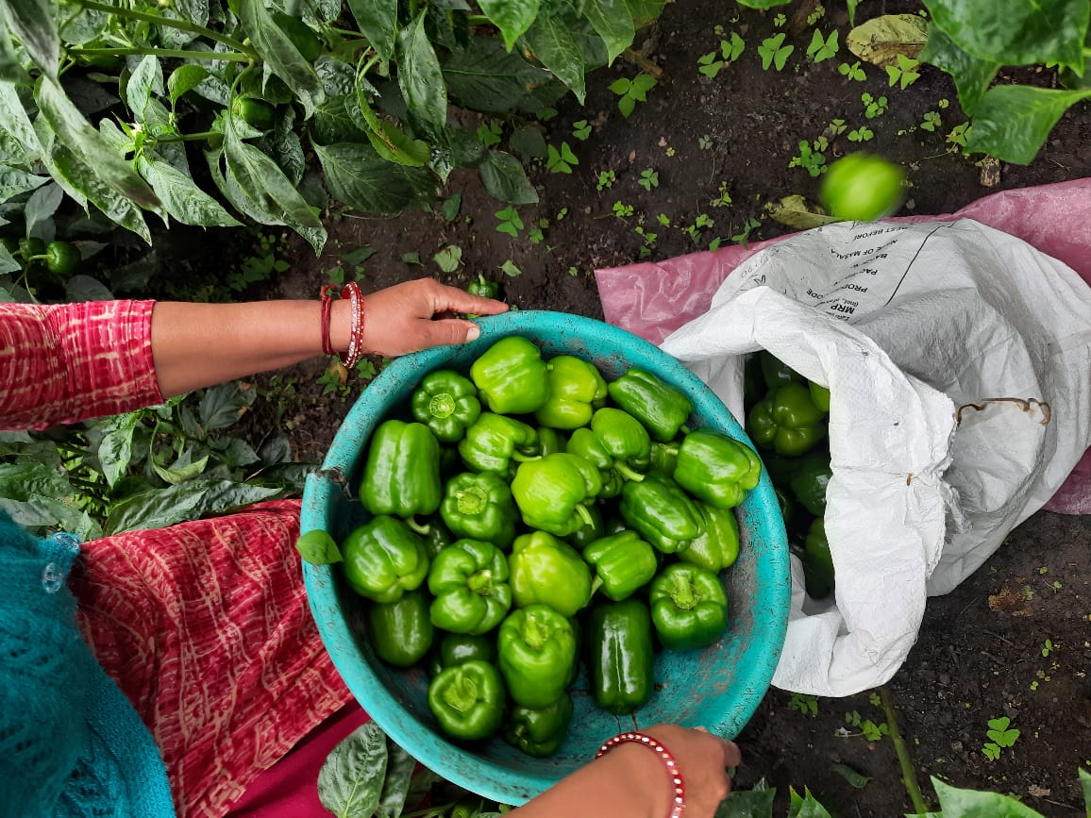
Alongside training in construction and maintenance, women were also trained in the preparation of soil for plantation; by mixing with well decomposed farm manure and the spacing requirement between seeds/seedlings. This basic training was required as for many, growing under cover is a new experience and the different methodology as well as types of crop viability was an importance part of the experience. As a result, beneficiaries are now growing varieties of vegetables such as cucumber, cauliflower, leafy vegetable, beans, potatoes, and tomatoes they previously were not in a position to grow successfully. Beneficiaries have also reported that their yields have increased by 40 percent. To date, a total of 48units have been undertaken benefitting 568 people directly and more than 2,250 indirectly.

Enterprise Diversification Units
Beekeeping and Honey Processing
Demand for improved beekeeping activities continues to be high as it is a seen as a mean to not only diversify food production and improve opportunities for food security but also to increase livelihood opportunities as a result of the by-products beekeeping represents. In addition, ATA has barefoot workers across the project area able to work with beneficiaries and support them in this activity. During this period, a further 20 units were undertaken. These units befitted over 213 people directly and a further 871 people indirectly. The potential for this activity across this and neighbouring locations means that demand far outweighs supply. Further training has also been undertaken in the areas where hives and colonies have already been established as a means of promoting sustainability and ensuring that local beneficiaries have the skills and confidence to maintain not only their hives, but also the welfare of their bee colonies.

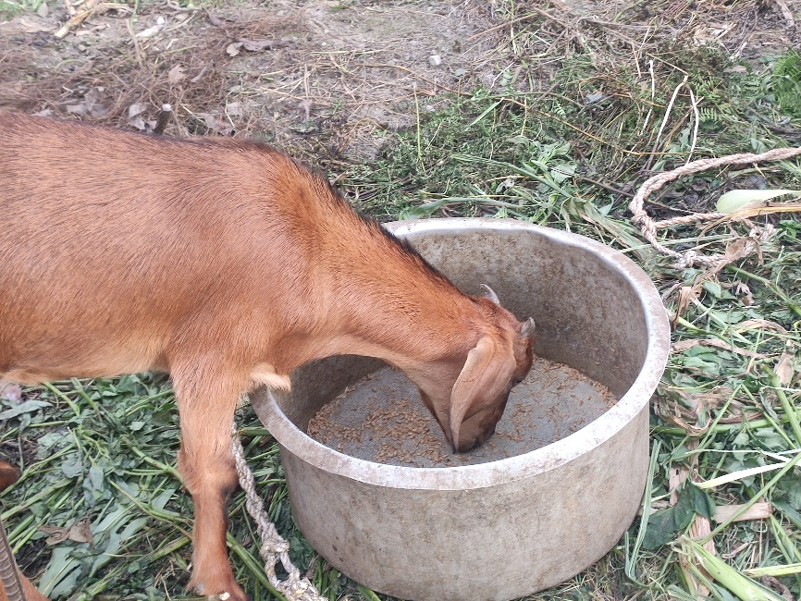
Goat Keeping
Goat farming has become very aspirational amongst beneficiaries as the investment costs are relatively minimal (feed, fodder and shelter) whilst the outputs are relatively high – including milk, meat and costs for spinning. With this in mind, in order to develop micro-enterprise opportunities, training in goat farming has been provided to communities across the beneficiary project area. The training was targeted at the most disadvantaged parts of the population and those who expressed the most interest in developing this as a micro-enterprise opportunity.

An initial 40 people were trained with the main objective of the training to enable the farmers learn suitable methods of goat farming. Once this was undertaken, those farmers who swished to pursue it in more detail were assisted in the development of small-scale goat farming initiatives and further dissemination was undertaken to surrounding communities to gauge further interest and opportunities. The ultimate aim is to not only promote micro enterprise opportunities but also use the initiative to improve food security, nutrition and development of by-products (such as wool).

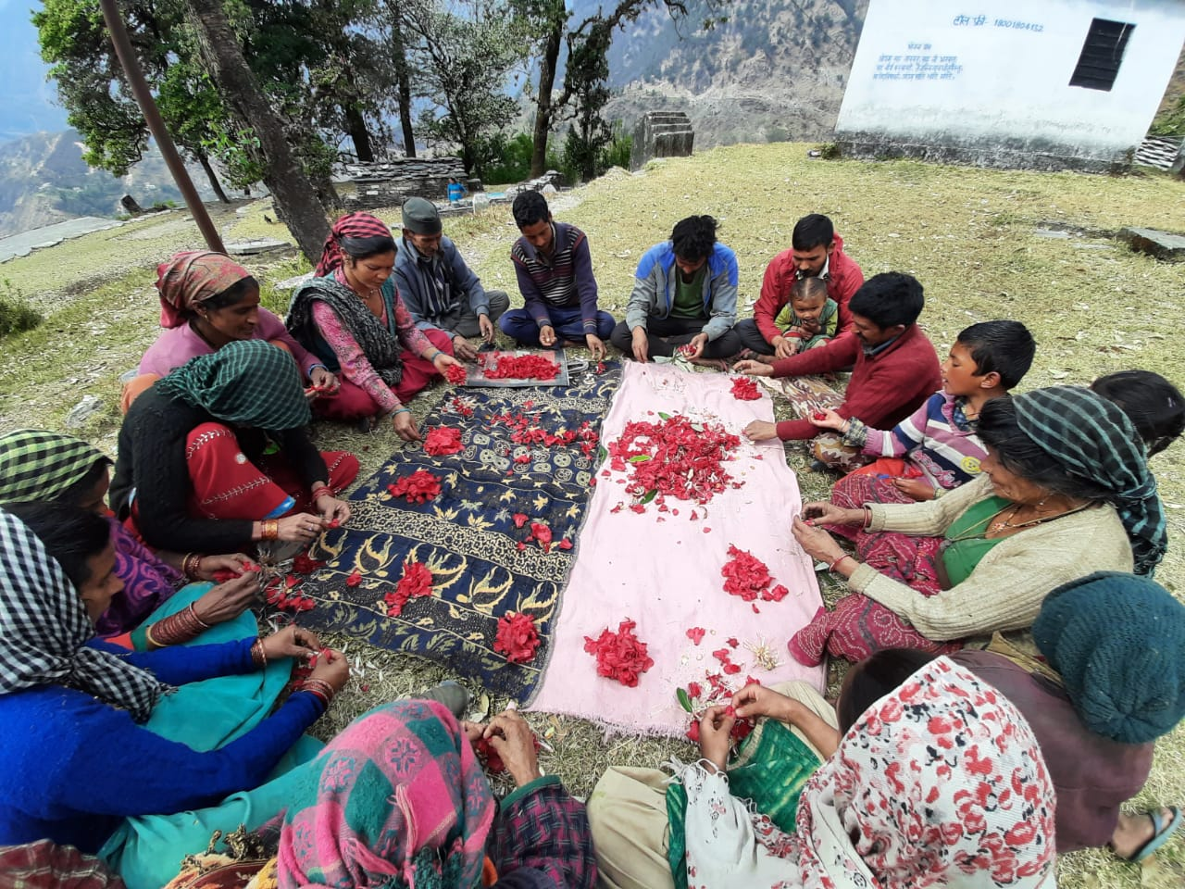
The local terrain is suitable for goat farming locally available wild fodder also the most suitable for the goats. This combined with the fact that 60% of the cost of rearing goats is spent on feed, means that this is the ideal initiative for these farmers. Given the various types of goat farming, it was decided that semi-intensive farming would be the most appropriate for the beneficiaries in this area. As such, a total of 30 families have now started goat farming. This will be extended over the next period. To date, a total of 310 people have directly benefitted from this activity with the potential for a further 1,835 to indirectly benefit.

Food Processing
Juice and Jam Making
The targeted beneficiaries include women from the most disadvantaged groups both socially and economically as a result of either their caste and background or their gender. Seasonal fruit gluts are common in good years, but traditionally much of this overabundance is lost because the fruit cannot be eaten or stored before it has spoiled. Here ATA is replicating a very popular and successful training in jam and juice making. This activity was repeated trying to involve as many mean as possible as a means to bring about some gender balance and equity as part of efforts to share workloads. This last period made the most of the locally available hedgerow and foraging plants to not only train in the making of cordials – such as rose and rose-hip. During this period a further 110 people were trained leading to this activity, to date benefitting more than 240 people directly with the potential to disseminate to an additional 3,470.

Candle Making
Candle making using beeswax is the most common by-product of beekeeping. The product is relatively simple to make for local commercial use. Beneficiaries were shown how to do this using simple techniques. Initial cleaning is undertaken. Once dried, the beeswax is then it is put into a pot of water and the water brought to a simmer so the beeswax melts. This is then allowed to cool and the beeswax floats to the top with the debris/honey separate and sinks. Once cleaned, simple molds were made along with wicks before once again melting the beeswax. Once melted, the wax is poured into the molds and left to cool before being ready for use. Beeswax candles burn cleaner and for longer – not only providing sources of light, but also with health benefits as they draw toxins out of the air. To date this has benefited more than 855 people with the potential to disseminate to an additional 2,030.

Nettle Processing
Nettles are prevalent in the project area, particularly in the wetter and colder locations. The plant grows in nitrogen-rich soil, usually blooms with pink or yellow flowers during the summer, and reaches a height of 2 to 4 feet. It is a shrubby perennial herb with prickly hairs on its stems and leaves with a chemical irritant that are released when one encounter against the plant, causing the burning or stinging sensation. The plant, if harvested correctly, can be a good source of food, medicine and with 35-45 species of nettle, diverse in use and flavour.
Nettle processing was introduced and training provided to benefit directly over 230 people and more than 900 people indirectly. Women were targeted to participate in this activity which sought to provide the means for beneficiaries to inform them of the nutritional and medicinal values of nettles, to learn harvesting and processing techniques, establish processing units to utilize existing crops of nettles and to grow specific species of nettle based on individual needs and requirements.

Solar Food Dryers
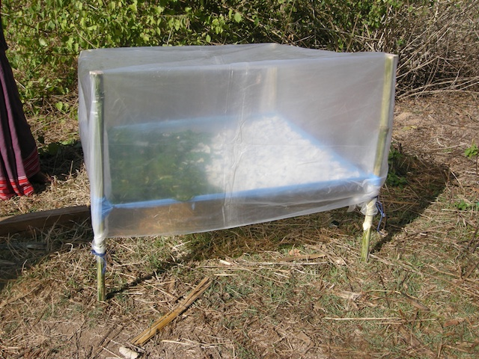
An alternative to storing food in its harvested state is to remove moisture prior to storage. This reduces the chance of rot, extends shelf life, and in many cases – and provided it is done correctly - also intensifies flavour and adds market value. Traditional methods of drying corn cobs and chillies work successfully, but since these products are often dried in the open air, food stuffs are often subject to contamination by dust and dirt, and are often also unprotected from pest damage or contamination during the drying process. Traditional drying also gives the farmer little control over the end result, and fruit products in particular tend to darken and wrinkle, reducing their palatability and affecting their market value.

The design of the dryer allows an increase in the temperature inside the box. As the temperature inside the box increases, the moisture of the goods kept inside the box evaporates. The evaporation process depends on the quantity of steam in the air and a regulating valve is built in to allow control. It is important that the temperature does not rise too high (usually over 60c) as this can result in the spoiling of produce. The dryer allows a safer drying process to control moisture at between 2 -12% depending on the product. This design has proven to be particularly popular because it allows scalability. This makes it more adaptable in the more remote project areas where production surpluses are lower. This technique lends itself to apples, bananas, guava, mango, pineapple, apricot and so on, especially with the addition of sugar or fruit acids to control darkening and shrivelling during the drying process. A total of 21 units have been constructed benefitting more than 260 people directly and 1,400 indirectly.

Fruit Tree Plantation
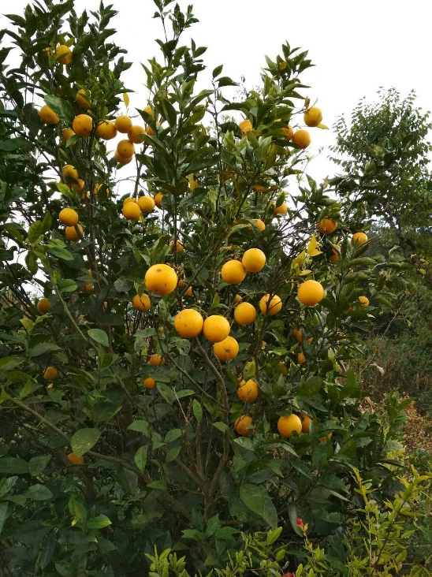
This was considered an effective way in which to demonstrate sustainable agriculture, how un-utilised land could be used for environmental regeneration, while also producing fruit which can be enjoyed while fresh or preserved for use over winter periods. Development of mother orchards ensures that scion stock are developed for future use and promote greater sustainability. The planting of fruit trees contributes to a diversified agricultural ecosystem. Fruit trees create microclimates which can assist in the production of other crops, while their roots can assist in consolidating soils and reducing erosion. Trees also provide fodder and timber as well as useful habitats for beneficial species such as spiders and other predatory insects, not to mention bees and other pollinating species. Fruit trees are an intrinsic and vital part of a diversified production system, and are one that yields benefits year after year, requiring little on-going input from the farmer. Species were chosen that were known to survive the unique environmental and climatic conditions of the project area. These have been chosen either for the fruit they will yield, or to provide the resilient rootstock that can be used in the future as a basis for grafting with more palatable or higher yielding varieties. Varieties planted include apple, orange, walnut, apricot, peach and pear.

Before the plantation, awareness raising training sessions were organised at all the project locations, to discuss the benefits of plantation in general and the particular benefits of planting fruit trees. This opportunity was also taken to highlight the importance of a balanced diet throughout the year. Participants were also encouraged to share their knowledge with other friends and families. A total of 350 fruit trees have been secured, benefitting 2,750 people directly and over 4,000 indirectly.

Training
Agricultural Training
Agricultural training helps communities improve their overall food security through the use of more integrated, sustainable and locally appropriate practices. These trainings, in combination with the use of greenhouses, kitchen gardens and hot beds/poly tunnels, will lead to a bigger diet diversification and consequentially, better health. Trainings to date, have been delivered based on the needs and skills level of each village. As the trainings were being organised to increase confidence, resilience, as well as imparting new skills, the trainers tried to meet participants at their existing skill level first. Skills were further then further developed using non-literacy dependent tools, such as practical demonstrations, explanations using local dialect as well as making good use of pictures and visual aids. Significant barriers women face in accessing training, including low literacy levels, domestic obligations and general mindset that trainings are primarily for men, among other things were addressed. During this period, 7 courses have been undertaken benefitting 115 people. These skills have been shared and disseminated to approximately a further 985 people. The training courses have also provided an opportunity to support beneficiaries in organising themselves into groups within their villages and to increase communication and problem solving through networking with neighbouring villages.

Financial

 |  | Budget |  | Spent |  | Balance
1 | Micro Enterprise Activities
1.1 | Food Production Units | 11,773.00 |  | 7,663.20 |  | 4,109.80
1.2 | Food Processing Units | 2,604.52 |  | 2,190.32 |  | 414.20
1.3 | BeeKeeping | 6,073.50 |  | 4,916.86 |  | 1,156.64
1.4 | Fruit Trees, Seeds and Saplings | 3,315.00 |  | 1,985.65 |  | 1,329.35
1.5 | Goats and Rabbits | 4,282.56 |  | 3,198.22 |  | 1,084.34
1.6 | Womens Health - Sanitary Pads etc | 4,705.03 |  | 0.00 |  | 4,705.03
1.7 | Mirco Irrigation | 5,958.24 |  | 5,976.87 |  | -18.63
1.8 | Skilled Technician | 298.00 |  | 148.98 |  | 149.02
2 | Training and Equipment
2.1 | Sustainable Livestock/Agriculture | 804.36 |  | 509.20 |  | 295.16
2.2 | Health and Hygiene Education | 530.76 |  | 0.00 |  | 530.76
2.3 | Juice/Jam and Curd Making | 1,161.42 |  | 1,312.44 |  | -151.02
2.4 | Food Preservation Training | 1,422.30 |  | 765.33 |  | 656.97
2.5 | Candle and Cream Making | 1,250.52 |  | 876.45 |  | 374.07
2.6 | Tailoring/Spinning | 1,430.04 |  | 0.00 |  | 1,430.04
2.7 | Transportation | 1,241.16 |  | 679.44 |  | 561.72
2.8 | Carbon Offsets/Regeneration | 975.00 |  | 0.00 |  | 975.00
2.9 | Monitoring and Evaluation | 3,625.44 |  | 2,114.84 |  | 1,510.60
 |  | 51,450.85 |  | 32,337.80 |  | 19,113.05

